**DELETE FILE ON DELETE MODEL DJANGO**

REF:

<https://stackoverflow.com/questions/17663809/deleting-uploaded-files-in-django>

IN ORDER TO ACHIEVE THIS GOAL, WE HAVE TO ADD SOME CONFIGURATION INSIDE THE REQUIRED MODEL:

1. IMPORT SOME DEPENDENCIES:

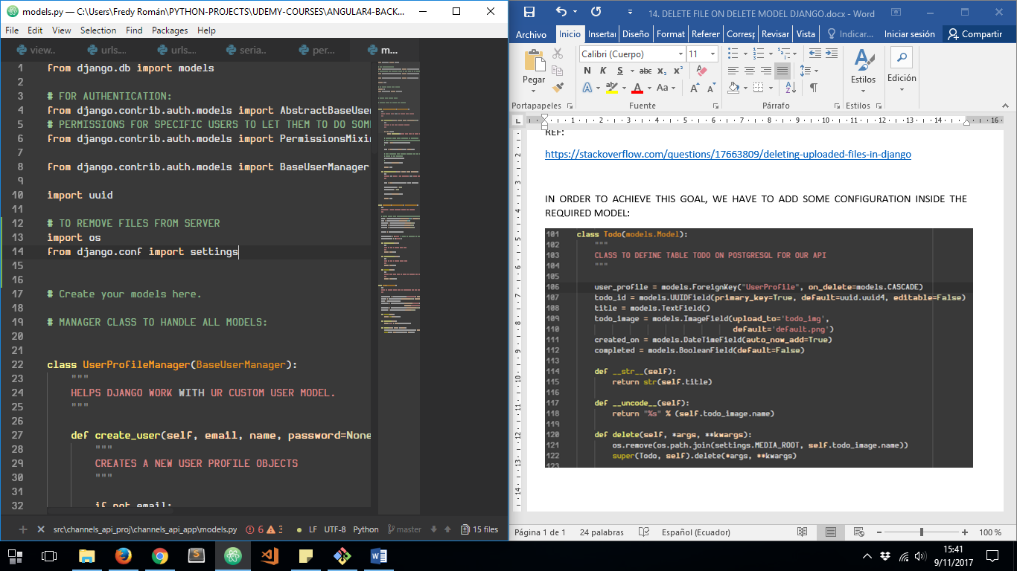

1. ADDING TWO FUNCTIONS TO ENSURE FILE DELETING

